**How to make a login and logout function in Laravel**

1. Based on past project

First create a route for the login, logout, and register (make sure the blade template for login, register have been made)

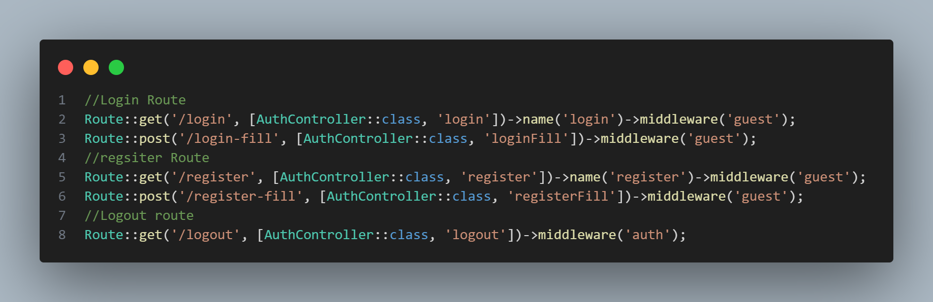

Next create a controller for all the routes created tom handle the logic (create auth controller by doing php artisan make:controller AuthController)

Login:

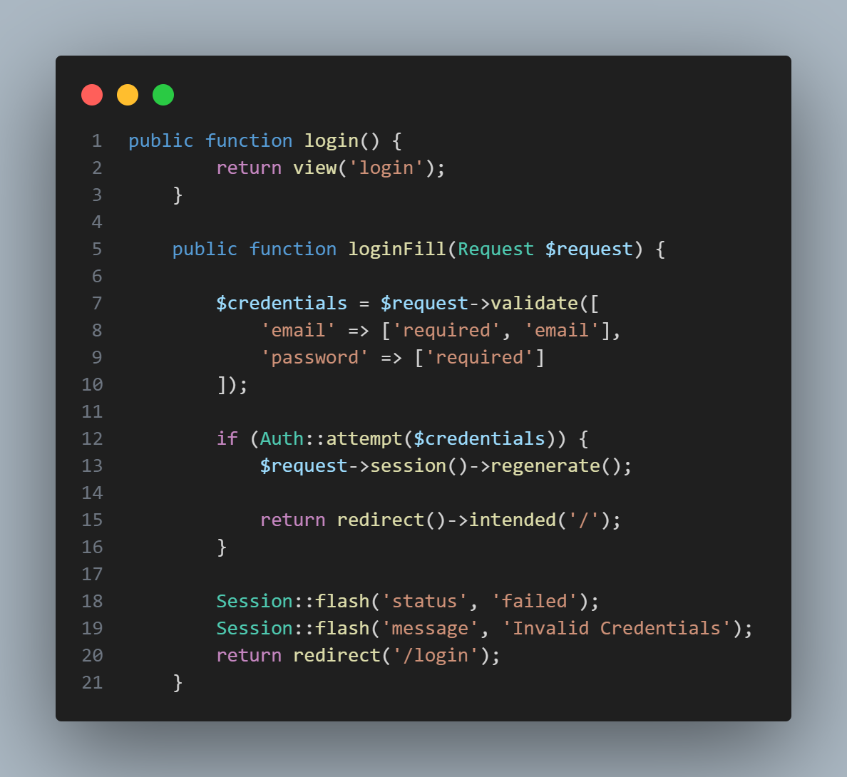

Register:

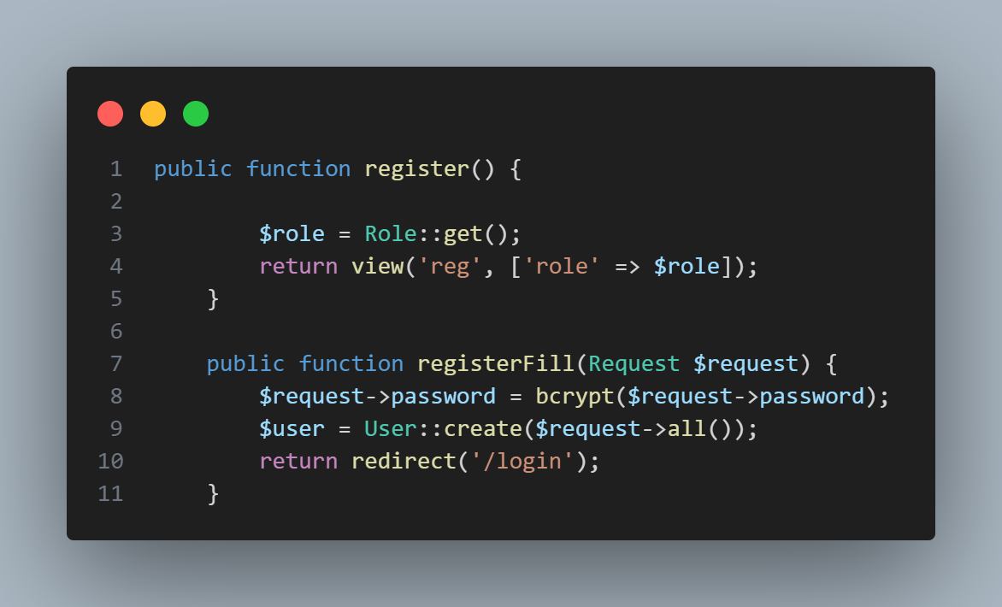

Logout:

